The following section uses .net azure storage emulation so the application can be developed locally without have in to publsh to the cloud.

## Preparing the project

1. Open visual web developer in administrator mode
2. Click new Project
3. Select ASP.NET Web Application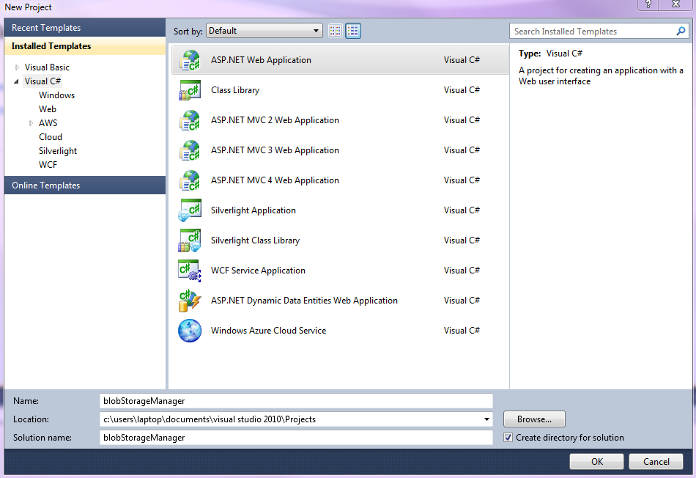
4. Give the project a suitable name and click OK
5. In solution Explore right click your project and select Add Windows Azure Cloud Service Project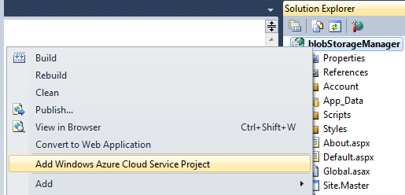
6. In solution manager select the newly create web role (it will have the same name as your project) and click Properties

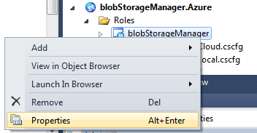

1. Click Settings and Add Setting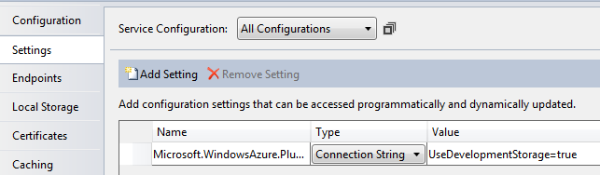
2. Name the Connection String developmentBlob and select Connection String. 
3. Click the three dots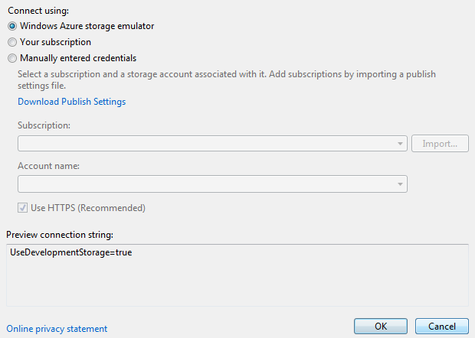
4. Select Azure storage Emulator and click OK
5. Click Save All icon

## Creating Containers

1. Create an new web form called Create.aspx
2. Drag a text box and button into the page
3. Name the text box txtContainerName and the button btnCreate
4. Change the button text to create new container
5. Go to Design view
6. Type Enter Container name beside or above the text box
7. Double click the button

### The code behind btnCreate_Click

1. Add the following lines 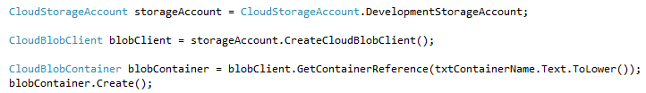
2. Red lines will appear under CloudStorageAccount, CloudBlobClient and CloudBlobContainer. Add the following namespaces to the top of the page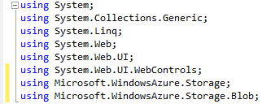
3. Run the code
4. Add a name for the new container
5. Click Create new Container

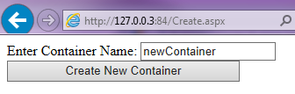

## Check if the container was created

1. In web developer click Database Explorer
2. Click Windows Azure 🡪Storage🡪(Development)🡪Blobs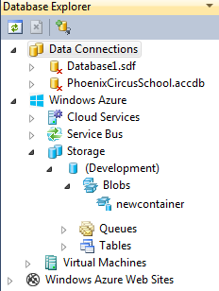
3. Your new container should be visible

# Blobs.aspx

This page vies the files storeing in a container

1. Create Blobs.aspx
2. Add a gridview
3. Name the gridview gvBlobs
4. Add the following code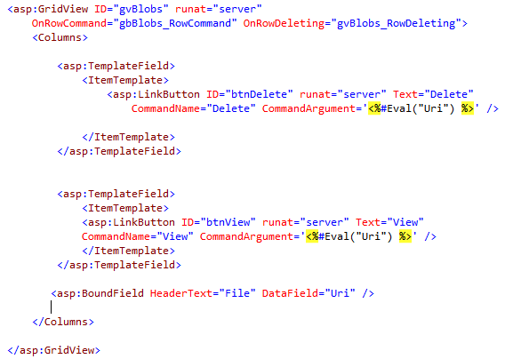
5. Next add FileUpload from the toolbox
6. Add a button under the file upload
7. Reaname the button to btnUpload, set text to Upload
8. Go to design view and double click the button